1. List the team members and the role they played in the project + class section

2. Project description

3. Requirements (15 points) – specifies high-level functionality to be implemented, the data that needs to be stored.

4. Database design rationale and/or a ER diagram along with a description of the tables (15 points).

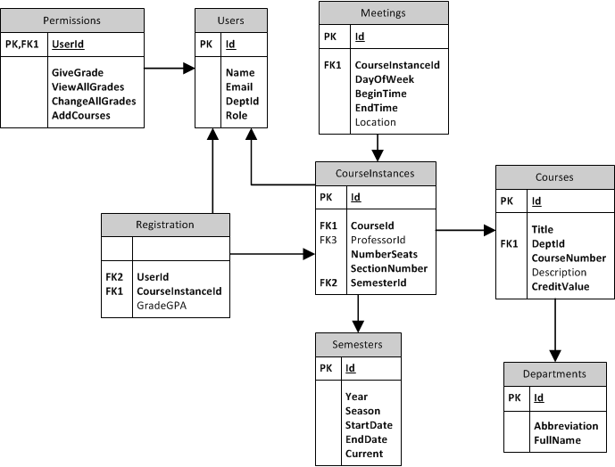

5. Table definitions and their illustration with sample data (10 points).

6. High-level description and code for the queries implemented & sample results of running the queries (15 points).

7. Comments about the challenges or other issues faced by the team (5 points).